+My answers are most probably wrong in some places so just make a comment/ change the answer in this case.

1. a) an =

Show that: for all $ϵ$ > 0, there exists N Є **ℕ** such that for all n > N

| an - l | <

Guess that limit, l = 0

| - 0| < <

1/ $ϵ$ < $\sqrt{3n-2}$

$⇔$ 1/ $ϵ^{2}$ < $3n-2$

$⇔$ $1/ϵ^{2}+ 2$ < $3n$

$⇔$ $1/{3ϵ}^{2}+ 2/3$ < $n$

So we have N($ϵ$) = ceiling($1/{3ϵ}^{2}+ 2/3$)

For all n > N($ϵ$), an converges by the $ϵ$- N method

b)

S = $\sum_{1}^{∞}{}1/(3n - 1)^{2} - 3$ = $\sum_{1}^{∞}{}1/9n^{2}-6n - 4$

This is similar to $1/n^{2}$ which we know converges so we shall use the limit comparison test (as i tried the comparison test but failed)

Let $1/n^{2}$ = ci  and $1/9n^{2}-6n - 4$ = ai

Show that $\lim_{n→∞}$ ai / ci exists

That is, $\lim_{n→∞}$ $1/9n^{2}-6n - 4$/ $1/n^{2}$ = $\lim_{n→∞}n^{2}/9n^{2}-6n - 4$

= $\lim_{n→∞}1/9-6/n - 4/n^{2}$

= 1/9

Therefore S converges

c)

g(x) = e3x + 1

g(-1) = e-2

g’(x) = 3e3x + 1

g’(-1) = 3e-2

g’’(x) = 32e3x + 1

g’’(-1) = 32e-2

g(n)(-1) = 3ne-2

g(x) =

Radius of convergence:

Do D’alembert’s limit ratio test with absolute value and r = infinity

ii) when f(x) or f(n)(x) for some n = ln(x) because ln(0) is not defined

2. a) [0, 1, -1] + 3/(w-3) [-2, 1, w]

b)

i) Nullity of A = the dimension of the null space of A = the number of elements in a basis for A

Kernel of A = null space of A = the set of vectors which maps onto the 0 vector / the neutral element

Pasting the relevant notes section here:

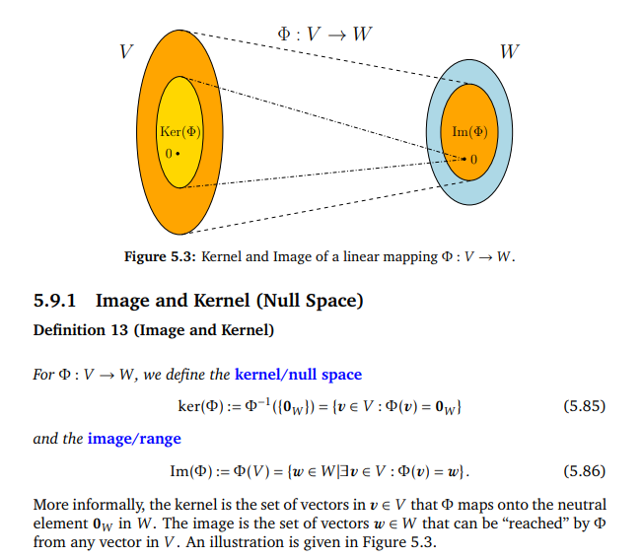

ii) rank = 2

iii) l: p = [-1, 2, 0] + ƛ[-2, 7, -1]

3a)

(x-1)(x-2)=0

(it should be (x-1)(x+3)=0)

A = {1, 2}

pA = {null, {1}. {2}. {1, 2}}

b)

2^(n^2) = 2^9 = 512

c)

f o g = 9x + 3

g o f = 9x + 1

g o h = 9x + 7

f o g o h = 27x + 21

d) f is the function modulo A by M, and F is a function as long as m is not zero, since then there are no possible values for R

F is not onto, because no value greater than M will get mapped to.

F is not one-to-one because f(x) and f(x + m) will both map to the same number

e) i) Reflexive: |X| = |X| by numeric reflexivity

Symmetric: |X| = |Y| -> |Y| = |X| by symmetry of numeric equality

Similar transitivity

Etc. would continue but I have ds to pass

*Graphs and Algorithms*

4) a. (i) 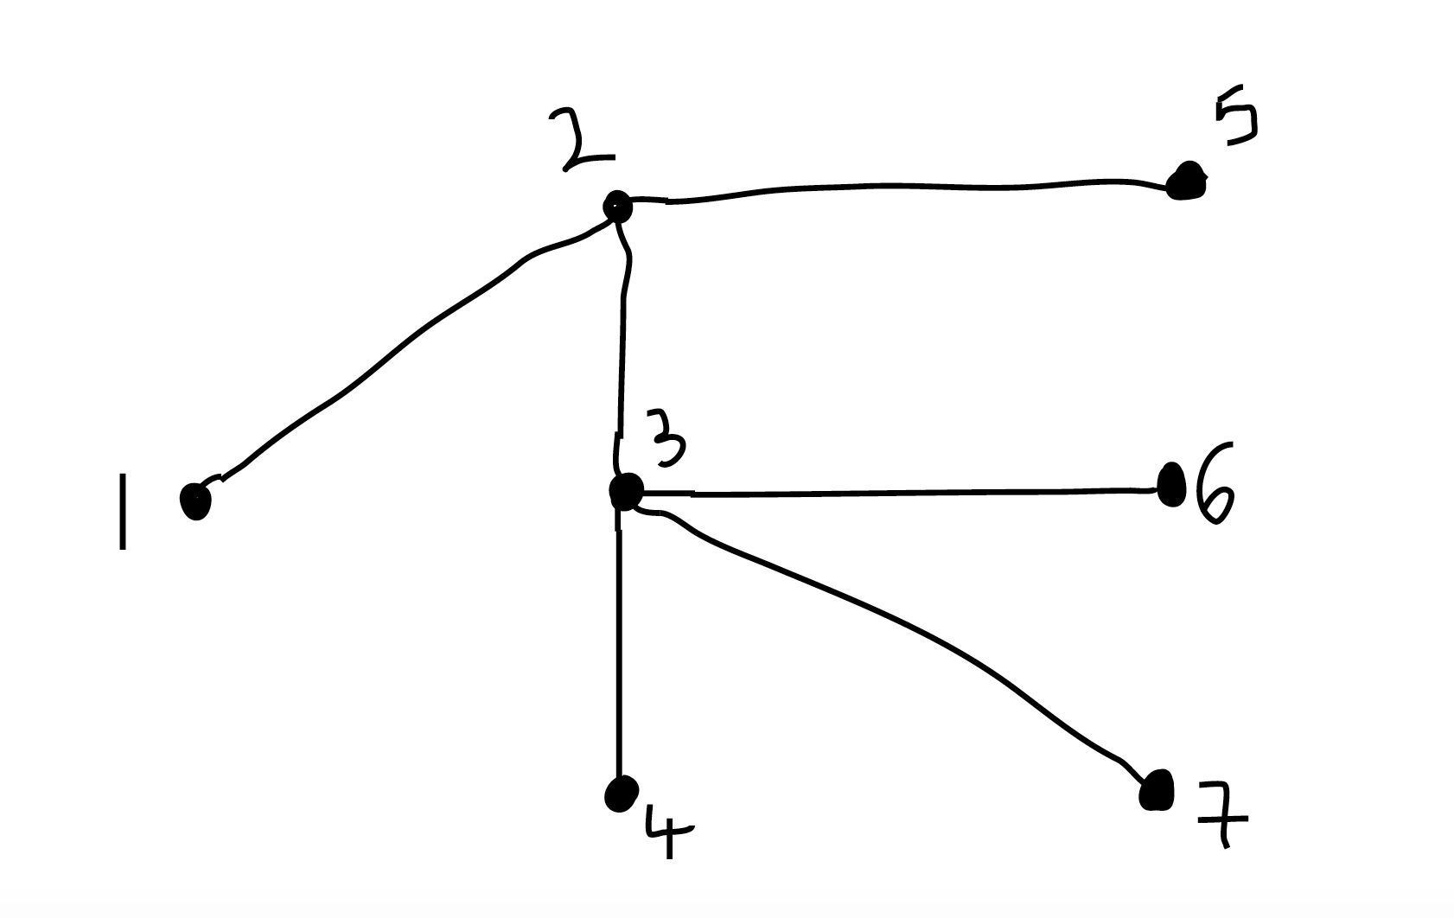

Nodes visited in the following order: 1, 2, 3, 4, 6, 7, 5

(ii) Suppose that when performing depth-first search we reach y before z. Then while executing the procedure call dfs(y) we will process z as it belongs to adj[y]. At this point we either add z to the tree as a child of y, or else z has already been processed during dfs(y) and is a descendant of y.

The case where we reach z before y is similar.

*[Taken from Graphs Exercises 3 Q10]*

b. (i) Shortest path from A to D is A-B-E-D, which has weight 12

00

T:

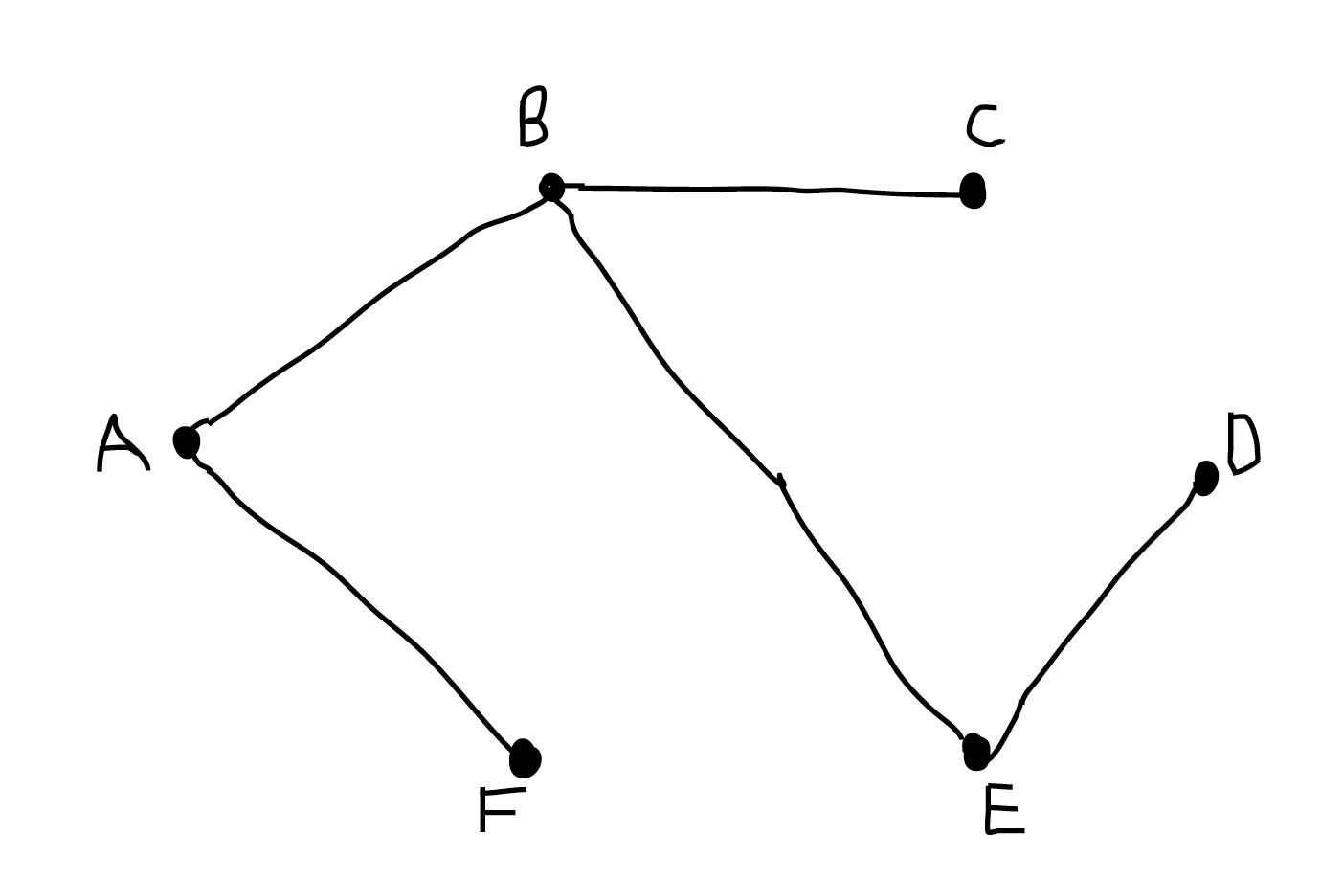

(ii) No, since we could obtain a spanning tree with a smaller weight by applying Prim’s algorithm to this graph. If we replaced BE with CE and AF with FE, we would get a spanning tree with weight (7-4) + (8-4) = 3 + 4 = 7 less than the spanning tree (T) from part (i). This new spanning tree is a minimum spanning tree.

(iii) No, because we could have picked BF instead of AF when applying Dijkstra above, and we would have got a valid shortest path tree (SPT).